Per instruction to follow this reference:

[2]- <http://docs.aws.amazon.com/gettingstarted/latest/deploy/envvar.html>

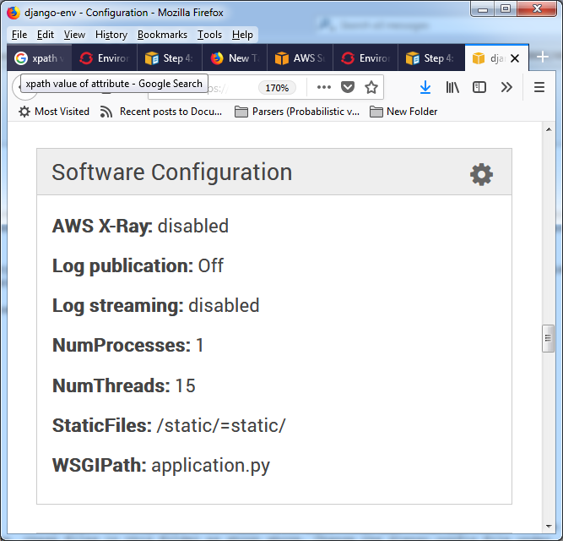Got to “Software Configuration”: No Environment Variables shown.

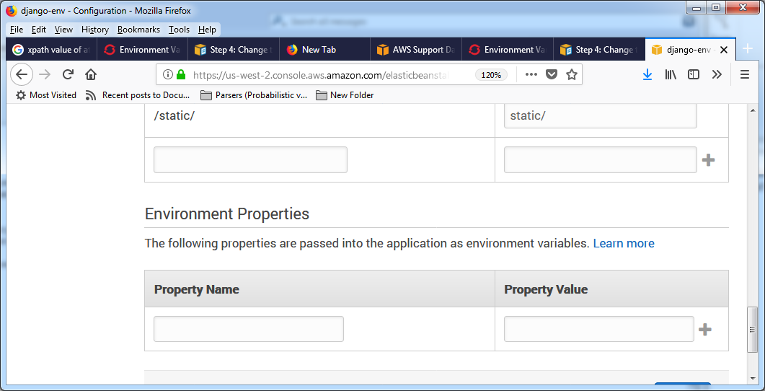Got to “Environment Properties”: I do not know what “Name” and “Value” should be for OPENSHIFT_REPO_DIR .

“Learn more” link ultimately takes me back to same Python-specific page I cited earlier (that shows this code):

import os

endpoint = os.environ['*API_ENDPOINT*']